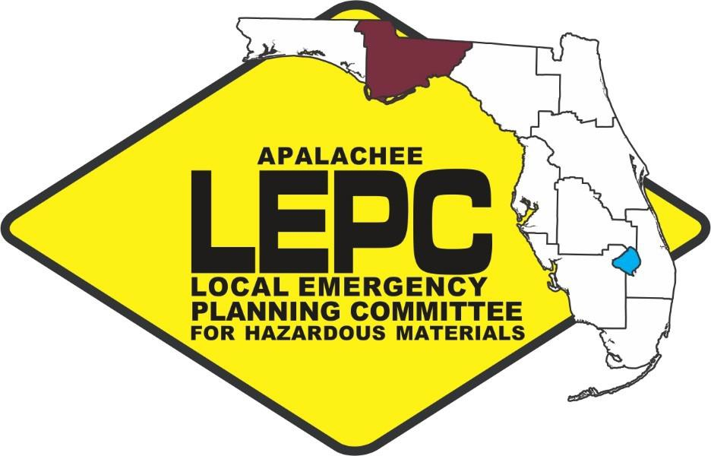

Apalachee Local Emergency Planning Committee

Quarter 1 Meeting
(July 1 – September 30)

November 29, 2022 @ 10:00 AM

Tallahassee Fire Training Division
Classroom 2

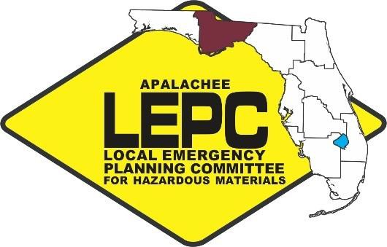
APALACHEE LOCAL EMERGENCY PLANNING COMMITTEE
2507 Callaway Road, Suite 200, Tallahassee, Florida 32303
Office (850) 488-6211 ext. 112 Fax: (850) 488-1616

Chairman: Kevin Peters
Vice Chairwoman: Gail Stewart
Training Task Force Member: Melissa Woehle
Staff to the Committee: Anthony Carpanini

Apalachee Local Emergency Planning Committee Meeting
Tuesday, November 29, 2022
10:00 AM Eastern

AGENDA

Call to Order, Roll Call, and Introductions

- Approval of Minutes* - See pages 5-7

  - September 21, 2022

Chairman’s Report – Kevin Peters

Staff Updates – Anthony Carpanini

Hazardous Material Releases

  - Recap of State Emergency Response Commission (SERC); LEPC Chairs and Staff; and SERC Training Task Force (TTF) Meetings

    - SERC Meeting Cancelled due to Hurricane Ian

  - Quarter 4 Training Overview

  - Upcoming Trainings

  - Hazard Analysis Update

  - 2022 Apalachee LEPC Planning Project

Apalachee LEPC Training Subcommittee Update

- Outreach

- Presentations

  - Gadsden County Hazard Analysis – Anthony Carpanini – ARPC

  - Chemical Facility Anti-Terrorism Standards, CHEMLOCK, and Flashpoint – Bing Crosby CISA

Other Business (Elected Officials, Emergency Management, Firefighting, EMS, Health, Law Enforcement, Environmental, Hospitals, Transportation, Media, Facility Owners/Operators, FEPA, Interested Citizens)

Public Comment

- Next Meeting Date – March 2023

- Adjournment*

* = Action Item

Apalachee Local Emergency Planning Committee
Tallahassee Fire Training Division
September 21, 2022 at 10:00 A.M.
Draft Meeting Minutes

- Call to Order, Roll Call, and Introductions

Chairman Peters called the meeting to order and asked for a rollcall of ALEPC Members. Staff indicated that there was a quorum present and thanked all those who attended the. The following members were present:

Members and Alternates:

Abrams, Chad Leon County Emergency Medical Services
Bevis, T.G. Tallahassee Community College
Carroll, Paula Jefferson County Emergency Management
Hall, Darryl Leon County Emergency Medical Services
Perkins, Heather Florida Department of Environmental Protection
Peters, Kevin Leon County Emergency Management
Rainey, Eve Florida Emergency Preparedness Association
Stewart, Gail Leon County Department of Health
Willis, Allen Tallahassee Fire Department
Woehle, Mellissa Florida Department of Environmental Protection
Guests:
Batts, Howell Florida Department of Health
Bouie, Willie Florida Division of Emergency Management
Bowden, Felecia National Weather Service
Bradshaw, Brian City of Tallahassee Fire Department
Crosby, Bing Department of Homeland Security
Favereau, Clifford Department of Homeland Security
Hard, David Department of Homeland Security
Lazzara, Justin Florida Division of Emergency Management
Levings, Christian Apalachee Regional Planning Council
Russell, Chris Environmental Protection Agency

Staff:

Carpanini, Anthony Apalachee Regional Planning Council

- Approval of Minutes

  - Allen Willis motioned to approve the minutes from the March 2, 2022 LEPC meeting. Melissa Woehle seconded the motion, and the minutes were passed unanimously.
  - Allen Willis motioned to approve the minutes from the June 15, 2022 LEPC meeting. Gail Stewart seconded the motion, and the minutes were passed unanimously

- Chairman’s Report

  - The Chairman deferred to staff to present on the latest SERC meeting.

- Staff Updates
  - LEPC staff spoke on hazardous materials releases in the region. Two 500-gallon totes of petroleum contact water and fuel were damaged and released their contents due to a fire in Tallahassee. There were no protective actions taken due to the release.

  - Staff informed in the committee that the last SERC meeting was held July 15, 2022. The meeting was conducted in Naples. Staff highlighted the following items from the meeting:
    - Training Task Force Chair Lamm notified the SERC of the 10-year anniversary Symposium to take place January 2023.
    - Mr. Dietrich from the Florida Division of Emergency Management discussed the operating trust fund and the recent legislative budget approval of recurring $450,000 to the fund.
    - There were no major releases requiring federal response in the state of Florida.
    - Mr. Rich Lavigne with the United States Coast Guard gave a presentation on the initial Offshore Hazmat Pilot Program which took place April 18-19 at Resolve Marine in Ft Lauderdale Florida.
    - Major Mandell discussed issues and training for first responders with fentanyl exposure and requested the SERC to encourage more training across the State.

  - Training Overview
    - Apalachee LEPC sponsored training:
      - Staff informed the committee the following trainings were held in the region over the past quarter.
        - 4-Hr HazMat Awareness in Tallahassee on May 4, 2022.
        - 8-Hr HazMat Detection in Tallahassee on June 29, 2022.
        - 4-Hr HazMat Awareness in Tallahassee on August 4, 2022.
        - Four 8- Hr. Technician Refresher Courses from August 15-August 18, 2022 in Tallahassee.
        - 4-Hour HazMat Awareness on September 21, 2022 in Marianna.
        - 4-Hour HazMat Awareness on September 22, 2022 in Monticello.

  - Outreach
    - Staff attended the 2022 Liberty County Build-a-Bucket event on June 16, 2022
    - Staff attended the 2022 Wakulla County Preparedness Expo held on June 25, 2022.
  - Commodity Flow Study Update
    - Staff presented to the Committee an update on the ongoing Regional Commodity Flow Study. Staff indicated that there will be a webinar on the completed Commodity Flow Study on September 27, 2022, at 10:00 AM.
  - Training Sub-Committee
    - Staff informed the committee of the formation of a training sub-committee and asked for volunteers.
- Public Comment
  - There were no comments made from the public.

- Presentations

  - ARPC Staff presented on the Calhoun and Gulf County Hazard Analysis. This reviewed the facilities storing EHS within the counties and noted those facilities deemed high risk due to their proximity to critical facilities.
  - Felecia Bowser with the National Weather Service in Tallahassee presented on an update to the 2022 Atlantic Hurricane Season.

- Other Business
  - Bing Crosby indicated that DHS would be presenting on CFATS/CHEMLOCK and Flashpoint at the next LEPC meeting in December.
  - Justin Lazarra with FDEM reiterated that FDEM will be updating their recognized regions to 10.
  - Eve Rainey representing FEPA announced that the FEPA annual meeting will be held the last week of July and that call for presentations has opened. Eve also indicated that EOC Mutual Aid Working Groups are available. Information regarding FEPA can be found at FEPA.org.
  - Paula Carrol with Jefferson County Emergency Management reminded the committee that there was going to be a 4-Hour HazMat Awareness course held in Monticello on September 22, 2022 beginning at 1:00 PM.
  - Allen Willis announced that Lance Butler with Tallahassee Fire Department will now be his alternate with the LEPC.
- Next Meeting Date –
  - The next Apalachee LEPC Meeting will be in December 2022.

- Adjournment
  - Meeting was adjourned at 11:00 A.M.

Signed: Attest:

Kevin Peters Anthony Carpanini
Apalachee LEPC Chairman Apalachee LEPC Staff

