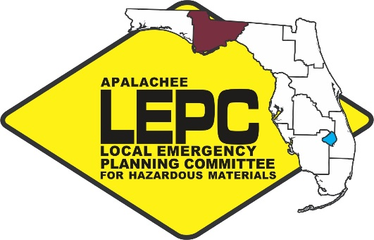
APALACHEE LOCAL EMERGENCY

PLANNING COMMITTEE
2507 Callaway Road, Suite 200, Tallahassee, Florida 32303
Office (850) 488-6211 ext. 102 Fax: (850) 488-1616

Chairman: Kevin Peters
Vice Chairwoman: Gail Stewart
Training Task Force Member: Melissa Woehle

Staff to the Committee: Apalachee Regional Planning Council

Apalachee Local Emergency Planning Committee Meeting
Tuesday, February 14, 2017
10:00 AM Eastern

***Capital Area Chapter of the American Red Cross***
1115 Easterwood Drive
Tallahassee, FL 32311

AGENDA

- Call to Order, Roll Call, and Introductions
- Approval of Minutes
- Chairman’s Report – Kevin Peters
  - Recap of State Emergency Response Commission (SERC); LEPC Chairs and Staff; and SERC Training Task Force (TTF) Meetings

  - Domestic Security Update: North Florida Regional Domestic Security Task Force (NFRDSTF)

  - Yatabe Award – GW Lupton

  - Certificates of Appreciation

- Staff Updates – Gina Mendicino
  - HMEP Planning Project – Updating SOPs for Hazardous Materials

  - HMEP Training
    - HazMat Symposium
    - Requests for HAZWOPER training
    - Dangerous Goods Shipping – Laymon Gray
  - HazMat Releases
    - Chemical Suicide on Capital Circle
    - Jet fuel tanker overturned on SR 12, Liberty County

- Other Business
  - ERG Pickup
- Public Comment
- Next Meeting Date – Tentatively scheduled for May 23, 2017
- Adjournment

Capital Area Chapter of the American Red Cross
1115 Easterwood Drive
Tallahassee, FL 32311

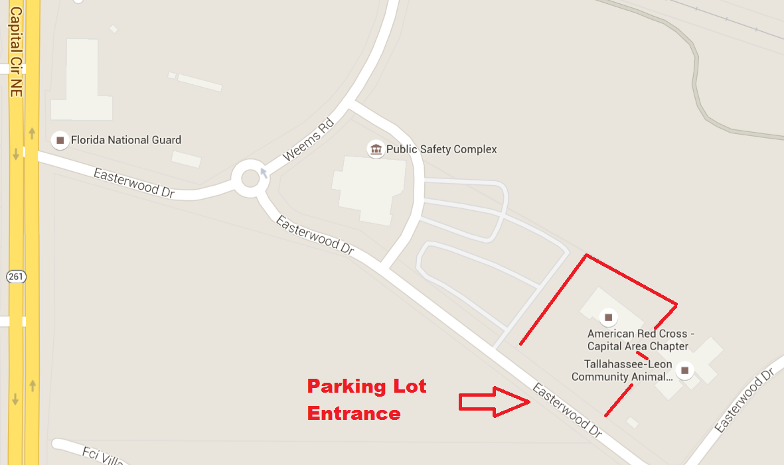

The Capital Area Chapter of the American Red Cross is located adjacent to the Tallahassee/Leon Public Safety Complex. The parking lot entrance is on Easterwood Drive. You are not required to sign in upon entering the facility.
Apalachee Local Emergency Planning Committee
Tallahassee Fire Department Training Division
2964 Municipal Way
Tallahassee, FL 32304
November 10 – 10:00 AM Eastern
Meeting Minutes

- Call to Order, Roll Call, and Introductions

Chairman Peters called the meeting to order, welcomed those in attendance, thanked those that traveled to the meeting at the Tallahassee Fire Department Training Division, and asked for self-introductions from those individuals present. Staff indicated that a quorum was present. Chairman Peters reminded all present to sign the attendance roster that had been passed out. The following members were present:

Members and Alternates
Abrams, Chad Leon County Emergency Medical Services
Dameron, Tress Franklin County Emergency Management
Ellerbe, Carol Jefferson County Emergency Management
Gray, Laymon Florida State University
Lara, Jonathan Florida Department of Environmental Protection
Leiva-Keause, Nancy Florida Department of Health
Nagy, Jennifer Leon County Division of Emergency Management
Notley, Todd Tallahassee Fire Department
Peters, Kevin Leon County Division of Emergency Management/Chair
Powers, Robby City of Tallahassee
Rainey, Eve Florida Emergency Preparedness Association
Stewart, Gail Department of Health – Leon County
Taylor, Brad Wakulla County Emergency Management
Teaf Christopher Florida State University
Woehle, Melissa Florida Department of Environmental Protection
Younger, Michael Tallahassee Community College

Guests
Bryant-Smith, Tonja Florida Department of Law Enforcement
Deanda, Brad Tallahassee Fire Department
Furlong, Michael Leon County Division of Emergency Management
Holliday, Kristina Florida Department of Law Enforcement
Runo, Ray Big Bend Health Care Coalition
Tammisetti, Sri City of Tallahassee

Staff
Mendicino, Gina Apalachee Regional Planning Council

- Approval of Minutes
Christopher Teaf motioned to approve the minutes of the November 10, 2016 Apalachee Local Emergency Planning Committee meeting. Eve Rainey seconded the motion and the minutes were passed unanimously.

- Chairman’s Report
  - SERC Training Task Force (TTF) and LEPC Chairs and Staff Meeting Recap
St. Augustine, FL – July14, 2016
Training Task Force Meeting Summary
    - State Fire College Update
- The hybrid training class has been receiving positive reviews. The State Fire College will continue to offer these classes as well as others.
- Chief Todd Notley agreed that the hybrid course worked out well for the shifts.
    - TTF Recommended Items for HazMat Training Trailer
- Several LEPCs have obtained a training trailer and have compiled a list as well as pictures of the equipment, which is available upon request.
- Obtaining a training trailer is not a priority of the Apalachee LEPC at present due to current demand from the Tallahassee Fire Department HazMat team.
LEPC Staff and Chairs Meeting Summary
    - HA Working Group Update – Dwayne Mundy
- The new state defined fields have been added to the Tier II Report.
- These new fields will have descriptions included to help facilities accurately report the new information.
- New fields will also be optional, so avoid confusing facility operators.
    - HazMat Symposium 2016 Update – Michelle Cechowski
- Registration for the HazMat Symposium is now open, and will take place in Daytona on January 17-19 in conjunction with the January SERC Conference.
- The Apalachee LEPC will be able to fully sponsor public sector employees and first responders with a hazardous materials background who wish to attend.
- The Yatabe Award presentation has been revamped and will include a nice backdrop and a page in the symposium brochure. The Apalachee LEPC’s Yatabe Award winner this year is GW Lupton.
    - AskRail
- AskRail is an app that can be used by first responders to identify the contents of rail cars.
- This service is in addition to, or possibly has been combined with, CSX Operations Response

  - SERC Meeting
St. Petersburg, FL – April 8, 2016
    - LEPC Appointments
- All appointments were approved unanimously.
    - Notification Discussion
- Both the Agriculture and Petroleum industries have expressed their concerns with the emergency rule for pollution notification. The majority of these concerns have been addressed through the course of public hearings and the setting of thresholds on reporting requirements.
- There are still concerns about who the reports need to be made to, as well as whether this reporting requirement is in addition to the current reporting requirements for the release of hazardous materials.
- Members discussed whether the Department of Environmental Protection was being included in the conversation to discuss who would have oversight of the new reporting rule. DEP members present informed the Committee that they were not being included in any of this discussion.
    - FOG Update
- The FOG update has been approved.
- The review process has begun for the next FOG update cycle.
  - Domestic Security Update: North Florida Regional Domestic Security Task Force (NFRDSTF)
    - RDSTF Meeting
- The next RDSTF Meeting will take place on December 6, 2016 at 1:00 P.M. at the Florida Department of Law Enforcement.
- At this meeting, the restructuring will be discussed.

- Staff Updates
  - 2016 ERGs
    - Most counties have picked up their allotment of ERGs.
    - Those counties that have not yet picked up their allotments will do so at the earliest opportunity.
  - Hazardous Materials Training
Date | Course | Location | Hours | Students
10/27/2016 | 8-hr OSHA Technician Level Refresher | Red Cross | 8 | 20

  - HMEP Planning Project – SOP and CEMP Updates
    - The Commodity Flow Study Placard Survey has been completed for the 2015-2016 HMEP Planning Project.
    - This survey will be used to create or update Standard Operating Guides for the release of hazardous materials for each county in the region. These SOPs will then be incorporated into each county’s CEMP.
- Other Business
  - Big Bend Health Care Coalition
    - BBHCC has been working with the FBI to conduct an active shooter exercise.
    - Membership has expanded to include over 100 agencies
    - BBHCC is creating a MYTEP, which is currently in development.
  - City of Tallahassee
    - Robby Powers is organizing two exercise scenarios. On December 8, there will be a scenario at the Leon County EOC involving topping the dam with flood waters. This will also provide the county with the opportunity to drill their emergency notification system. The second scenario will be held on December 13 at the Capital Area Chapter of the American Red Cross and will involve a HazMat component of a natural gas release in a neighborhood.
  - FEPA Annual Meeting
    - The FEPA Annual Meeting will take place January 30 – February 3 in Orlando, Florida. This year’s meeting will involve the topics of mass care and recovery after the events of the Pulse nightclub shooting and the Hurricanes Hermine and Matthew.
  - TFD HazMat Response Truck Demo
    - The Tallahassee Fire Department Hazardous Materials Team was present to demonstrate their HazMat response truck to the Apalachee LEPC. Members of the TFD HazMat team gave a tour of their response truck, demonstrated equipment, and answered all questions by members of the Apalachee LEPC.

- Public Comment
There was no public comment.

- Next Meeting Date and Location
The next Apalachee LEPC meeting will take place tentatively on February 2, 2016.

- Adjournment
Chairman Peters thanked everyone for their attendance and participation. There being no further business, the meeting adjourned at 12:30 P.M. Eastern Time.

SIGNED: ATTEST:

_______________________________ _______________________________________
KEVIN PETERS GINA MENDICINO

